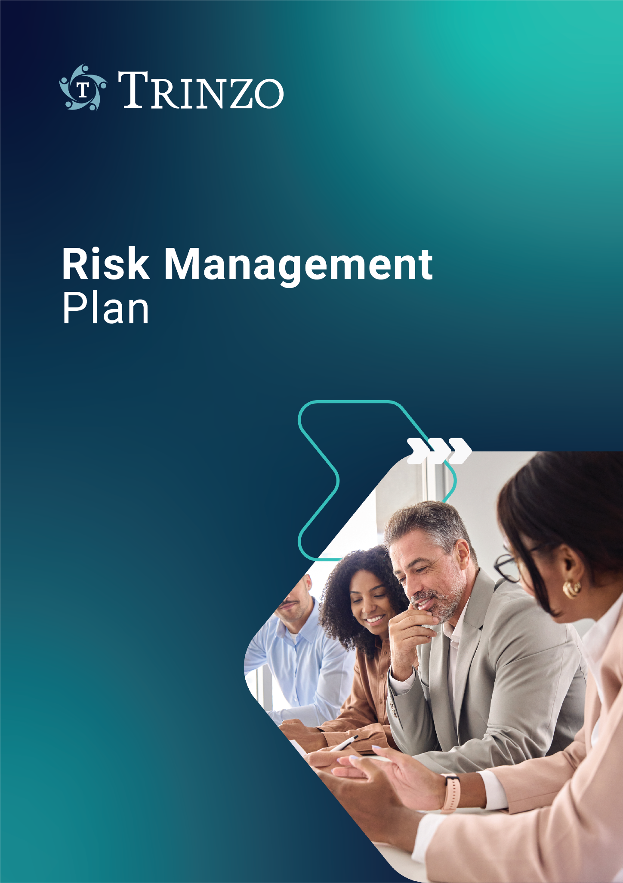

Guidelines for Using

This Template

The following report template should be modified to suit your company QMS and referenced as part of your own risk management procedure. It contains all of the basic elements needed to comply with the risk management report requirements of ISO 14971:2019.

To ensure clarity, we've included instructions and explanations throughout this template, which are indicated with blue italic text. Before approving a document based on this template, please remove all instructions and explanations. The remaining non-blue text is provided as examples, which should be edited to fit your specific needs.

**Top Tip:**

* If creating a new product, plan as much as possible during the project's planning phase.
* If updating an existing product or expanding a product line, only minor updates to the plan may be necessary.
* Ensure the wording aligns with the wording used in your QMS, for example, roles identified may differ.

**Learn More**

We provide instructions and example text in all of our templates, but for a broader understanding of risk management and the planning process, consider joining us at one of our [Risk Management for Medical Devices](https://www.meddevsolutions.co.uk/riskmanagement) public training courses.

Want us to help with your risk management plan? Book your [free consultation](https://www.meddevsolutions.co.uk/contactus) call with one of our industry-leading experts today.

|  |  |  |
| --- | --- | --- |
| **Report Approvals** | | |
| **Responsibility** | **Signature** | **Date** |
| Author |  |  |
| QA |  |  |
| Project Leader |  |  |

## Objective of the Risk Management Plan

This plan identifies the basic risk management activities for (product XXXXXXX/product family XXXXX). The objective is to ensure that appropriate risk management has been considered through all aspects of this product’s life cycle from concept to disposal.

## Scope of Risk Management Activities During the Medical Device Lifecycle

### 2.1 Identification of devices

#### Provide a list of devices covered by this plan (adjust table headers to reflect company terminology, devices must be uniquely identified to ensure all devices are appropriately covered):

|  |  |  |
| --- | --- | --- |
| Ref/Cat/Part no: | Name/model | Basic UDI/UDI-DI |
|  |  |  |
|  |  |  |
|  |  |  |

### 2.2 Description of the medical device/s

#### (Enter description of the product here including intended purpose, indications for use, contraindications, performance details, relevant components and sub-assemblies, materials of construction and mechanism of operation)

### 

### 2.3 Product lifecycle stages

#### The following table identifies the basic product lifecycle and associated project activities for (product XXXX):

This can be depicted visually in the following table:

#### (These RM activities are identified in ISO 14971:2019)

#### Note – this table should reflect your own company design & development process stages. Points in grey should align with both your D&D process and RM process, change as required.

#### This table is intended to meet the requirements of ISO 14971 4.4a detailing the lifecycle phases of the device vs RM activities. The table should be amended to reflect the product lifecycle stage.

|  |  |  |  |  |  |  |
| --- | --- | --- | --- | --- | --- | --- |
| **Lifecycle Stage**  **RM activity** | **1**  **Feasibility** | **2**  **Input** | **3**  **Design** | **4**  **Qualification** | **5**  **Release** | **6**  **End of Life (EOL)** |
| **5.2 - Intended Use** |  |  |  |  |  |  |
| **5.3/5.4 - Hazard ID** |  |  |  |  |  |  |
| **5.5 - Risk Estimation** |  |  |  |  |  |  |
| **6 - Risk Evaluation** |  |  |  |  |  |  |
| **7 - Risk Control** |  |  |  |  |  |  |
| **7.1 - Risk Control Options** |  |  |  |  |  |  |
| **7.2 - Implementation** |  |  |  |  |  |  |
| **7.3 - Residual Risk** |  |  |  |  |  |  |
| **7.4 - Benefit-risk** |  |  |  |  |  |  |
| **7.5 - Risk arising from RCM** |  |  |  |  |  |  |
| **7.6 - Completeness** |  |  |  |  |  |  |
| **8 - Overall Residual Risk** |  |  |  |  |  |  |
| **9 - Risk Review** |  |  |  |  |  |  |
| **10 - Production &**  **Postproduction activities** |  |  |  |  |  |  |

## 

## Timetable for the Implementation of Processes and Activities

#### Enter information regarding when the risk assessment will be conducted initially, when the key milestones are expected etc. This may refer to original project data such as the project development plan.

## Assignment of Responsibilities and Authorities

#### Note – table an example only and should reflect your own organization (Ref ISO 14971 4.4b).

|  |  |  |
| --- | --- | --- |
| **Task** | **Responsible** | **Approval authority** |
| Risk Analysis | Project Leader | Risk management team |
| Risk Evaluation | Project Leader | Risk management team |
| Risk Control | Project Leader | Risk management team |
| Evaluation of overallresidual risk acceptability | Project Leader | Risk management team |
| Risk management review | Project Leader | Head of EngineeringQA/RA Manager orSenior QA/RA Engineer |
| Production andpost-production activities | QA/RA department | QA/RA Manager orSenior QA/RA Engineer |

## 

## Reviews

#### Review of the risk management activities will occur during enter details here of when risk management activities will be reviewed (e.g., design phase meetings etc) Detail if there are any standard reviews that occur due to your procedural requirements, such as annual review and when they are expected to occur. (Ref ISO 14971 4.4c).

## 

## Criteria for Risk Acceptability

#### Decide if you are putting in particular criteria that is individual for a particular product/product family here, or if you are going to refer to your risk management procedure if it contains the criteria for these devices as an alternative option (these must be appropriate for the particular medical devices covered by this plan). You should refer to your policy for determining risk acceptability criteria and also define acceptance criteria for when probability of occurrence cannot be determined (again based on your policy e.g. utilising the severity score alone and assuming probability is 100%). An example diagram appears below, but you must ensure it aligns with both your policy and procedure. (Ref ISO 14971 4.4d).

|  |  |  |  |  |  |  |
| --- | --- | --- | --- | --- | --- | --- |
|  | Severity | 1 | 2 | 3 | 4 | 5 |
| Probability | 1 |  |  |  |  |  |
| 2 |  |  |  |  |  |
| 3 |  |  |  |  |  |
| 4 |  |  |  |  |  |
| 5 |  |  |  |  |  |

## 

## Method to evaluate the overall residual risk and criteria for overall residual risk acceptability.

#### In this section you need to explain how you are planning to assess overall residual risk and how you are going to determine acceptance. This is a method description only at this stage. Consideration should be given to the overall risk left after control measures have been implemented and how they have been controlled, for example, have you reduced risk through safety by design, or have you had to use a lot of protective measures? A before and after snapshot of the risks mapped out onto the acceptability criteria can work here if your procedure allows it. Alternative options include plotting residual risk vs benefit to determine overall residual risk acceptability. It can also include gathering and reviewing data and literature for the medical device being considered and similar medical devices on the market and can involve judgment by a cross-functional team of experts with application knowledge and clinical expertise (Ref ISO 14971 4.4e) .

## Verification Activities

#### Verification of implementation of risk control measures and verification of effectiveness of risk control measures will be performed.

#### The verification of risk control measure implementation will be recorded in the risk assessment document by documenting objective evidence such as test reports, part numbers, drawing numbers etc.

#### The effectiveness of risk control measures will be ascertained by assessing the level of risk after risk control measure implementation. Activities such as user acceptance testing, clinical investigation, usability testing, will be employed to verify the effectiveness.

#### Postproduction information will be used to determine if a risk control measure remains effective throughout the lifetime of the device. (Ref ISO 14971 4.4f)

## Risk Management Team

The Risk Management Process team is defined below:

#### (Also include Q&RA team members responsible for post market activities)

#### (Responsibility should include their area of expertise and whether they are a reviewer or approver of documents)

Evidence of qualifications is held by *HR* and is available on request. Internal training records are held within the *QMS*.

|  |  |  |
| --- | --- | --- |
| **Name** | **Position** | **Responsibility & area of expertise** |
|  |  |  |
|  |  |  |
|  |  |  |

## 

## Tools Used in the Risk Management Process

#### Identify which tools (for example, risk analysis techniques, verification, and validation techniques, etc.) will be used. Also take care in using the right tools for the right parts of the Risk Management Process.

#### Consider the following risk analysis techniques (not exhaustive):

|  |  |
| --- | --- |
| Tool | Useful for: |
| HAZOP | Hazard and Operability study - Identification of hazards associated with deviating from the normal operation. |
| FMECA | Failure Modes Effect and Criticality Analysis - Identification and assessment of hazards to component level (bottom up) – Note, this method is not sufficient on its own to comply with 14971, so a modified approach can be used to include all 14971 requirements as needed. |
| FTA | Fault Tree Analysis - identification of root causes and assessment of hazards (top down) |
| Fishbone/Ishikawa | Identification of root causes of hazards |
| ETA | Event Tree Analysis - Identification of events caused by a hazard. |

## 

## Activities related to collection and review of relevant production and post-production information.

The following activities will be used for collection and review of relevant production and post- production information: *(Ref ISO 14971 4.4g)*

#### Change control procedure XXXXXXXXX Complaint handling procedure XXXXXXXXX

#### Medical Device Reporting and Vigilance procedure XXXXXXXXX Corrective and Preventive Action Procedure XXXXXXXXXX Product Field Action procedure XXXXXXXXXX

#### Post Market Surveillance procedure XXXXXXXXX PMS Plan XXXXXXXX

#### Also include any relevant production monitoring information such as inspections or test criteria.

#### 

The Risk Management Report will verify that these methods are in place and are effective.

## Revision History

|  |  |  |
| --- | --- | --- |
| **Revision**  **Number** | **Revision**  **Date** | **Description of Changes** |
|  |  |  |

Need Further Support In Risk Management?

Meddev Solutions provides training to the top medical device manufacturers around the globe, with as well as notified bodies and competent authorities. Delivered by our team of industry-leading experts, our training courses are jam-packed with practical information.

By joining our 2-day Risk Management for Medical Devices course, you‘ll gain invaluable insight from industry experts and practical knowledge to help you navigate risk in your organisation.

**LEARNING OBJECTIVES**

* Understand the purpose and structure of ISO 14971
* Understand the key terminology used throughout ISO 14971
* Describe and understand the elements of an effective risk management process
* Gain a solid understanding of the different techniques that support risk analysis
* Explain the documents requirements for the risk file and when updates are required
* 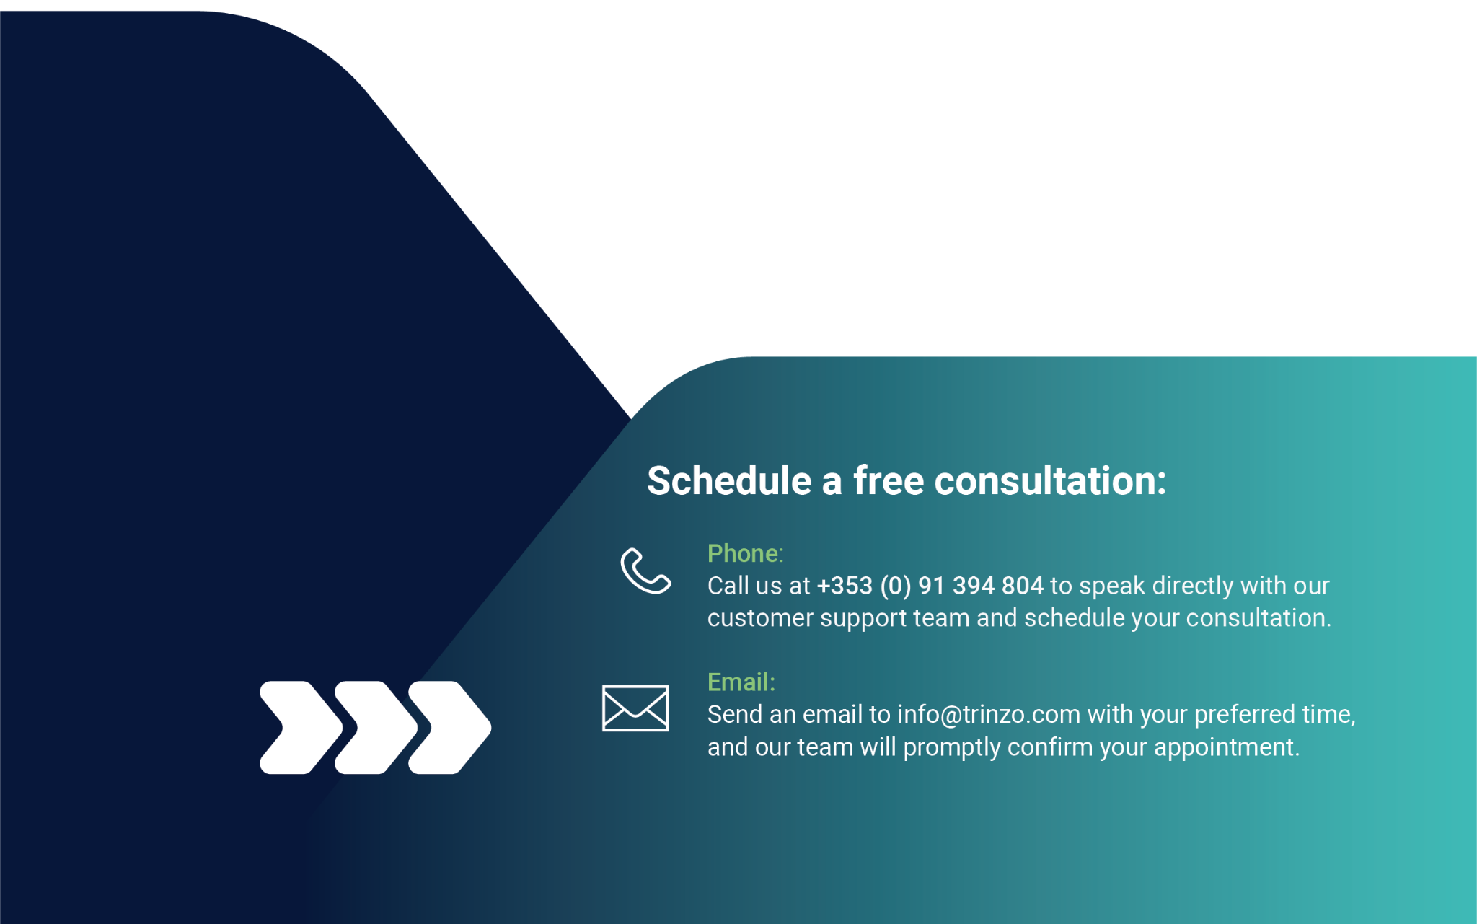Outline the role of ISO/TR 24971 in risk management.

