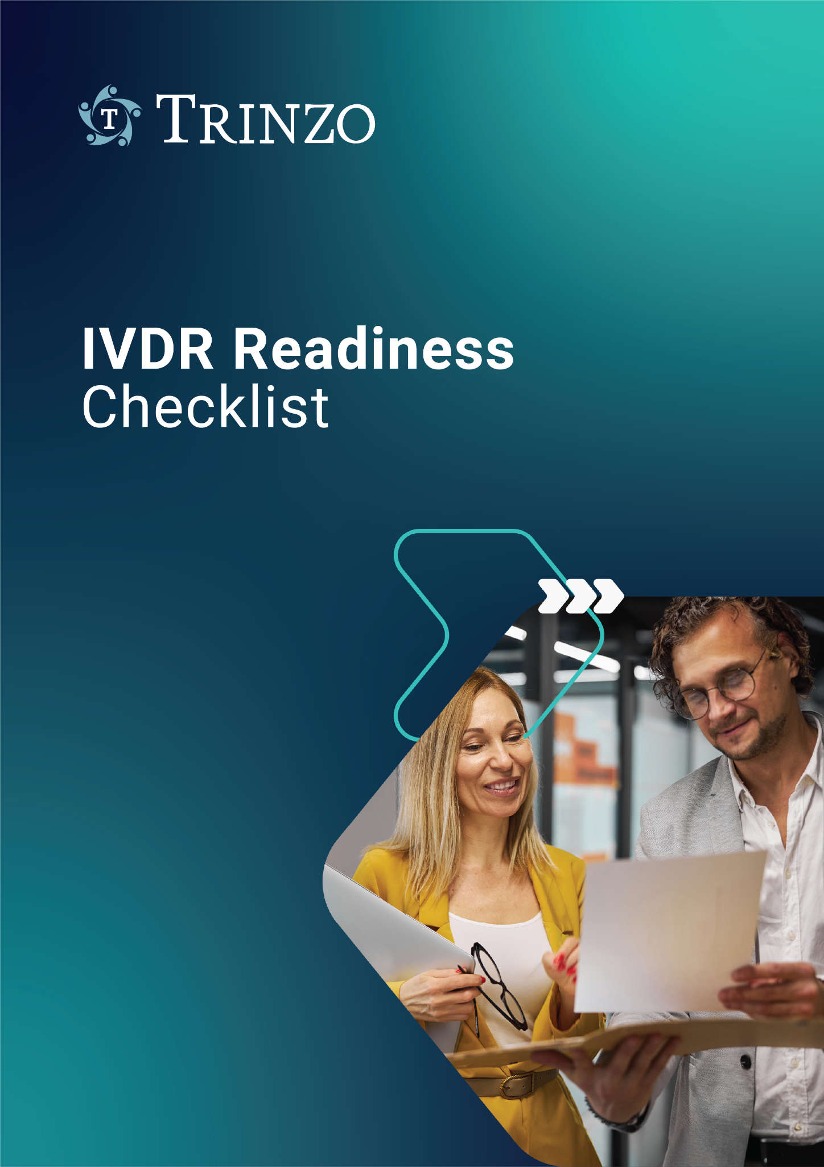

# EU IVDR Readiness Checklist

This checklist has been created by our industry-leading experts to provide you with an insight into your level of preparedness and understanding of the EU IVDR.

## Introductory Questions

|  |  |  |  |
| --- | --- | --- | --- |
| Are you aware of the In Vitro Diagnostics Regulation (IVDR) and how it will impact your company? | | | |
| * Yes | * No | * Not Sure | * N/A |
| Are you aware of the In Vitro Diagnostics Regulation (IVDR) and how it will impact your company? | | | |
| * Yes | * No | * Not Sure | * N/A |
| Are you planning to take advantage of soft transition for your devices? | | | |
| * Yes | * No | * Not Sure | * N/A |
| Have you done a gap analysis of your current state and the requirements of the IVDR? | | | |
| * Yes | * No | * Not Sure | * N/A |
| If gaps have been identified, do you have a plan in place and are working towards addressing any shortfall? | | | |
| * Yes | * No | * Not Sure | * N/A |
| Have you identified any additional resources that are required to fulfil your obligations under IVDR (human, budgetary, and training)? Resourcing is also required by Section 6 of ISO 13485, so it’s important to have plans in place to meet these requirements for an ISO 13485 QMS audit. | | | |
| * Yes | * No | * Not Sure | * N/A |
| Do you need to appoint an EU Authorised Representative, according to the requirements in Article 11? | | | |
| * Yes | * No | * Not Sure | * N/A |
| If you do require an EUAR, do you have a mandate in place covering all of the EUAR tasks as outlined in Article 11, Section 3? | | | |
| * Yes | * No | * Not Sure | * N/A |
| Do you need an importer as per article 13? | | | |
| * Yes | * No | * Not Sure | * N/A |
| Does your distributor understand and agree to their obligations as per article 14? | | | |
| * Yes | * No | * Not Sure | * N/A |

## Quality Management System

|  |  |  |  |
| --- | --- | --- | --- |
| Do you have an ISO 13485 accredited Quality Management System (QMS) in place? | | | |
| * Yes | * No | * Not Sure | * N/A |
| If your QMS is solely based on ISO 13485 certification, have you identified and implemented the IVDR QMS requirements according to Article 10, Section 8, that are not covered by ISO 13485?  For example (not exhaustive), procedures for:   * Performance evaluation in accordance with (Article 56 and Annex XIII IVDR) * Risk management as set out in Section 3 of Annex 1 * Processes for reporting of serious incidents and field safety corrective actions in the context of vigilance | | | |
| * Yes | * No | * Not Sure | * N/A |
| Are you prepared for annual surveillance audits, and unannounced audits alike? | | | |
| * Yes | * No | * Not Sure | * N/A |
| Have you written a Regulatory Strategy for IVDR compliance, as per Article 10, Section 8(a) and Annex IX, Section 2.2 (c) of the regulation? | | | |
| * Yes | * No | * Not Sure | * N/A |
| Does your strategy identify all applicable legal requirements, classifications, conformity assessment routes, and any methods that will be employed to meet these requirements? | | | |
| * Yes | * No | * Not Sure | * N/A |
| Have you identified a Person Responsible for Regulatory Compliance (PRRC) within your organisation, according to the requirements in Article 15? | | | |
| * Yes | * No | * Not Sure | * N/A |
| Does this person have the necessary expertise to fulfil their role, in relation to experience and/or formal qualifications? | | | |
| * Yes | * No | * Not Sure | * N/A |

## Classification and Conformity Assessment

|  |  |  |  |
| --- | --- | --- | --- |
| Have you classified your products under IVDR, according to Annex VIII, and identified the most appropriate conformity assessment route? | | | |
| * Yes | * No | * Not Sure | * N/A |
| Have you adequately recorded your justification for choosing the applicable classifications, and the related conformity assessment route(s)? | | | |
| * Yes | * No | * Not Sure | * N/A |
| Have you engaged with a Notified Body, if required? | | | |
| * Yes | * No | * Not Sure | * N/A |
| If so, have discussions been initiated on a sampling plan for Class B and Class C devices? | | | |
| * Yes | * No | * Not Sure | * N/A |

## Annex I, II, and III requirements

|  |  |  |  |
| --- | --- | --- | --- |
| Have you conducted a gap analysis on your product Technical Files according to the requirements of Annex II? | | | |
| * Yes | * No | * Not Sure | * N/A |
| If gaps have been identified, do you have a plan in place and are working towards addressing any shortfall? | | | |
| * Yes | * No | * Not Sure | * N/A |
| Do you meet the post-market surveillance requirements according to Articles 78 - 81 and Annex III?  *Remember - Annex III requirements are applicable for all device classifications as of 26th May 2022, regardless of the transition provisions.* | | | |
| * Yes | * No | * Not Sure | * N/A |
| Do you have a clear understanding of the General Safety and Performance Requirements (GSPRs) that apply to your products, and a justification in place for those that do not apply? | | | |
| * Yes | * No | * Not Sure | * N/A |
| Do you have a completed GSPR checklist in place for each product? | | | |
| * Yes | * No | * Not Sure | * N/A |
| Does this checklist identify the methods by which the GSPR is met, the standards used to meet the GSPR, and the precise location of any supporting data? | | | |
| * Yes | * No | * Not Sure | * N/A |
| Are your risk management files compliant with EN ISO 14971:2019? | | | |
| * Yes | * No | * Not Sure | * N/A |
| Have you performed a Benefit/Risk analysis according to the requirements of Chapter I, Annex I? | | | |
| * Yes | * No | * Not Sure | * N/A |
| Have you assigned UDI and Basic-UDI codes to your devices? | | | |
| * Yes | * No | * Not Sure | * N/A |
| Are you aware of the UDI transition dates for the different device classifications, and how these dates relate to your product portfolio? | | | |
| * Yes | * No | * Not Sure | * N/A |
| Are you familiar with the documentation that requires reference to the Basic-UDI? | | | |
| * Yes | * No | * Not Sure | * N/A |

## Annex I, II, and III requirements

|  |  |  |  |
| --- | --- | --- | --- |
| Have you taken into account all applicable packaging levels for your UDI assignment? | | | |
| * Yes | * No | * Not Sure | * N/A |
| Have you registered your establishment in Eudamed? *You must register by 2024* | | | |
| * Yes | * No | * Not Sure | * N/A |
| Have you registered your products in Eudamed? *You must register by 2026 Q2* | | | |
| * Yes | * No | * Not Sure | * N/A |

**Add up your responses and receive your score below:**

Tally up your ‘yes’ answers above and find out where you are in your IVDR journey.

* **Between 1 - 10** Let’s discuss your current IVDR transition in further detail.
* **Between 10 - 20** You’ve made a good start but to help you get you further along, our expert team can help.
* A screenshot of a phone call

  Description automatically generated**Between 20 - 30** Great job! If you feel you require any additional support, please don’t hesitate to contact us.
* 