

As per Article 86 of the MDR, the Periodic Safety Update Report (PSUR) is a new requirement under the regulation and is applicable to class IIa, IIb and class III devices. Lower risk class I devices require a Post Market Surveillance Report (PMSR). At a minimum, class IIb and class III PSURs should be updated annually, and throughout the lifecycle of the device. Class IIa PSURs must be updated when necessary, and at least every two years. The PSUR forms part of the technical documentation as outlined in Annexes II and III of the MDR.

Manufacturers of class III or implantable devices must submit their PSURs to their notified body via Eudamed. The notified body will review the content and provide an evaluation of the report. Both the PSUR and the notified body evaluation will then be available to competent authorities via Eudamed.

Manufacturers of class IIa and class IIb devices are not required to upload their PSUR to Eudamed, but the report must be made available to their notified body, and competent authorities upon request.

PSUR inputs include, but are not limited to:

* Complaints,
* Non-conformances,
* CAPAs,
* Field Safety Corrective Actions,
* Literature searches related to the subject device,
* Literature searches related to equivalent or similar devices,
* Vigilance database searches related to similar devices,
* The outcome of trend analysis,
* The outcome of benefit-risk analysis.

The establishment of robust post-market surveillance, vigilance, and risk management processes will facilitate the seamless creation of the PSUR. The data inputs should be reviewed regularly, at defined intervals, so that nothing unexpected arises when the time comes to compile the data into the PSUR.

MDCG 2022-21 should be consulted for detailed guidance on compilation of the PSUR.

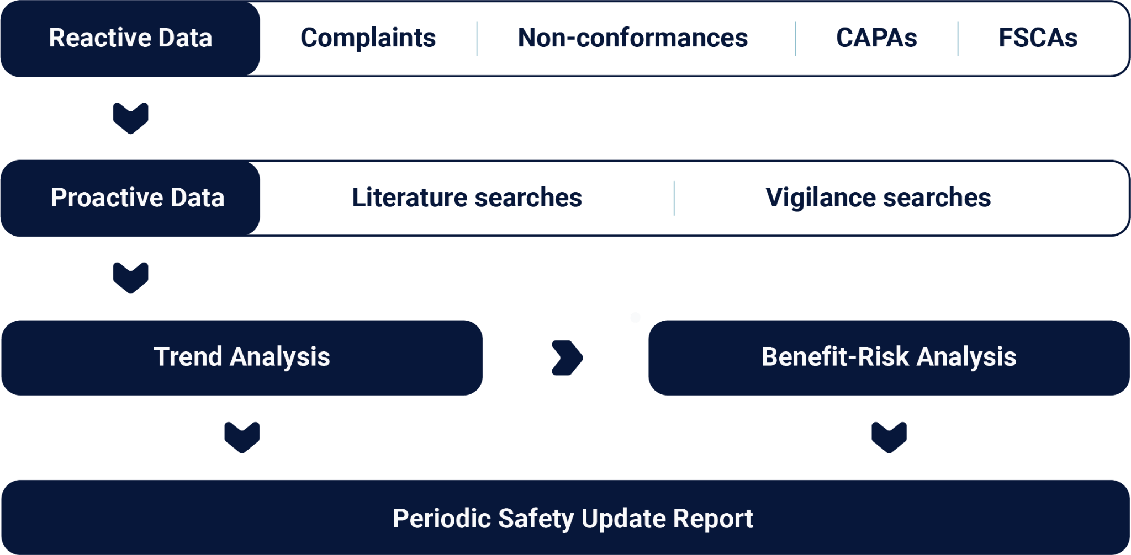

## Periodic Safety Update Report

## For

## Device name

**Manufactured by:** *Manufacturer name*

*Manufacturer address*

**Notified Body Name:** *Insert notified body name*

**Notified Body address**: *Insert notified body address*

**Notified Body Number:***Insert notified body number*

|  |  |
| --- | --- |
| PSUR reference number: |  |
| PSUR version: |  |
| PSUR period: | *DD-MM-YYYY – DD-MM-YYYY* |

## Executive Summary

This report provides a summary of the results and conclusions of the analysis of the post-market surveillance data that was gathered as part of the activities outlined in the post-market surveillance plan, as required by Article 84 of the Medical Device Regulation 2017/745. It also provides a rationale for, and description of, any preventive and corrective actions that have been undertaken during the relevant period.

Actions arising from the previous PSUR are summarised as follows:

**Table 1: Previous actions**

|  |  |  |  |
| --- | --- | --- | --- |
| Action  reference: | PSUR  reference: | Description of action: | Taken by: |
|  |  |  |  |
|  |  |  |  |
|  |  |  |  |

Based on the analysis of the collected data, it is concluded that the benefit-risk profile of the device has not been (or has been) adversely impacted / remains unchanged. Update as appropriate

## Device Information

**Table 2: Device information**

|  |  |  |
| --- | --- | --- |
| Device Name: |  | |
| Device Code: |  | |
| Device Classification: | *.* | |
| Classification Rule: |  | |
| Basic UDI-DI: |  | |
| EMDN Code: |  | |
| Intended Purpose: |  | |
| Relevant Date: | *DD-MM-YYYY* |  |
| Device Status: |  | |

|  |  |
| --- | --- |
| PSUR reference number: |  |
| PSUR version: |  |
| PSUR period: | *DD-MM-YYYY – DD-MM-YYYY* |

## Post-Market Surveillance Data

This section summarises the main findings of the Post-Market Clinical Follow-Up activities, referencing the data gathered in the applicable period for the market use of the device, complaints, non-conformances and CAPAs, and the outcomes of the literature searches that have been undertaken.

* 1. **Market Use Data for Given Period**

**Table 3: Market use data**

|  |  |
| --- | --- |
| Sales Volume EU: |  |
| Sales Volume WW: |  |
| User Characteristics: |  |
| Estimated Usage Frequency: |  |

* 1. **Complaints**

**Table 4: Complaints**

|  |  |  |  |  |  |
| --- | --- | --- | --- | --- | --- |
| ID | Description | Date | Market | Corrective  Action Taken | Status |
|  |  |  |  |  |  |

*Add rows for multiple results.*

* 1. **Non-Conformances**

**Table 5: Non-Conformances**

|  |  |  |  |  |  |
| --- | --- | --- | --- | --- | --- |
| ID | Description | Date | Root Cause | Corrective  Action Taken | Status |
|  |  |  |  |  |  |

*Add rows for multiple results.*

* 1. **Corrective and Preventive Actions (CAPAs)**

**Table 6: CAPAs**

|  |  |  |  |  |  |
| --- | --- | --- | --- | --- | --- |
| ID | Description | Date | Root Cause | Action Taken | Status |
|  |  |  |  |  |  |

*Add rows for multiple results.*

|  |  |
| --- | --- |
| PSUR reference number: |  |
| PSUR version: |  |
| PSUR period: | *DD-MM-YYYY – DD-MM-YYYY* |

* 1. **Literature Search (device specific)**

*Refer to the literature search protocol according to the PMPF.*

**Table 7: Device specific literature search results**

|  |  |  |  |  |  |
| --- | --- | --- | --- | --- | --- |
| Database | E.g. PubMed, Cochrane Library | | | | |
| ID | Date | Title | Author(s) | Relevant | Justification for non-relevance |
|  |  |  |  |  |  |

*Add rows for multiple results.*

*Repeat table for each database searched.*

* 1. **Literature Search (similar devices)**

**Table 8: Literature specific literature search results**

|  |  |  |  |  |  |  |
| --- | --- | --- | --- | --- | --- | --- |
| Database | E.g. PubMed, Cochrane Library | | | | | |
| Device | Date | ID | Title | Author(s) | Relevant | Justification for non-relevance |
|  |  |  |  |  |  |  |

*Add rows for multiple results.*

*Repeat table for each database searched.*

|  |  |
| --- | --- |
| PSUR reference number: |  |
| PSUR version: |  |
| PSUR period: | *DD-MM-YYYY – DD-MM-YYYY* |

* 1. **Field Safety Corrective Actions**

**Table 9: FSCAs**

|  |  |  |  |  |  |  |
| --- | --- | --- | --- | --- | --- | --- |
| ID | FSN REF | Description | Date | Affected Market(s) | Corrective  Action Taken | Status |
|  |  |  |  |  |  |  |

*Add rows for multiple results.*

* 1. **Database Searches**

**Table 10: Vigilance database searches**

|  |  |  |  |  |
| --- | --- | --- | --- | --- |
| Database | E.g. FDA, BfarM | | | |
| Device | Incident Date | Incident Description | Relevant | Justification for non-relevance |
|  |  |  |  |  |

*Add rows for multiple results.*

*Repeat table for each database searched.*

|  |  |
| --- | --- |
| PSUR reference number: |  |
| PSUR version: |  |
| PSUR period: | *DD-MM-YYYY – DD-MM-YYYY* |

## Trend Analysis

Outline any trends identified from the PMS data that was gathered and analysed during the period in question.

*E.g. X complaints were received indicating that there was an issue with XYZ. This was confirmed by X internal incidents. Incidents of this nature have increased by X% since the last PSUR period and therefore, XYZ has been put in place to address these issues.*

## Benefit-Risk Determination

Consider the following :

* Did any of the post-market surveillance data trigger an update to the device Risk Management File?
* Have any new risks been introduced?
* Have any new benefits been identified?
* Did it have any effect on the existing benefit-risk analysis?
* Does the benefit-risk of the device remain acceptable?
* Provide a justification/explanation where action/update was not deemed necessary.

## Conclusion

Consider the following :

* Summarise the findings from sections 3-5,
* Conclude what impact any relevant data has had on the device benefit-risk determination,
* Highlight any required updates that are required to the PMCF plan as a result of these findings.
* Include any limitations to the data contained in the report (e.g. reduced sales), and any impact this might have on the overall assessment

**Table 11: Vigilance database searches**

|  |  |  |
| --- | --- | --- |
| PSUR Contributors | | |
| Responsibility | Name | Signature and Date |
| Author |  |  |
| QA Representative |  |  |
| RA Representative |  |  |
| Marketing Representative |  |  |

*Add rows for additional contributors*

|  |  |
| --- | --- |
| PSUR reference number: |  |
| PSUR version: |  |
| PSUR period: | *DD-MM-YYYY – DD-MM-YYYY* |

|  |  |
| --- | --- |
| Proposed date of next PMS review: | *DD-MM-YYYY* |

# Need assistance in compilation of your Periodic Safety Update Report?

**Trinzo can support you in achieving MDR compliance in your labelling by:**

* Carrying out the related literature and vigilance searches on your behalf,
* Analysing your data to identify any emerging trends or effects to benefit-risk determination.
* Compiling your PMS and vigilance data into a format appropriate for PSUR submission (to technical documentation or Eudamed, as applicable).

